|  |  |
| --- | --- |
|  | THỰC HÀNH OPENSTACK CLOUD  XÂY DỰNG HỆ THỐNG MẠNG SỬ DỤNG WEB Dashboard |

Nhóm học phần:

1) Mã Sinh viên, Họ và Tên:

2)

3)

MỤC LỤC

1. Kiểm tra thông tin mạng 2

2. CÁC CHỨC NĂNG CỦA OPENSTACK DASHBOARD 3

2.1. Project tab 3

2.1.1. Compute tab¶ 3

2.1.2. Volume tab¶ 3

2.1.3. Network tab¶ 3

2.1.4. Object Store tab¶ 3

2.2. Admin tab 3

2.2.1. Overview tab¶ 3

2.2.2. Compute tab¶ 4

2.2.3. Volume tab¶ 4

2.2.4. Network tab¶ 4

2.2.5. System tab¶ 4

2.2.6. Identity tab 4

2.2.7. Settings tab 4

3. TRUY XUẤT HỆ THỐNG OPENSTACK THÔNG QUA Dashboard 5

4. [Menu Project] Xem thông tin hệ thống OpenStack 6

4.1. API Access 6

4.2. Project/Compute/Overview 7

4.3. Project/ Compute/ Instances 7

4.4. Project/ Compute/ Images 8

4.5. Project/ Compute/ Key Pairs 8

4.6. Project/ Network/ Network Topology 9

4.7. Project/ Network/ Network Topology 10

4.8. Project/ Network/ Routers 10

4.9. Project/ Network/ Security Groups 11

4.10. Project/ Network/ Floating Ips 11

5. Memu Admin 12

5.1. Admin/ Overview 12

5.2. Admin/ Compute/ Hypervisors 12

5.3. Admin/ Compute/ Host Aggregates 13

5.4. Admin/ Compute/ Instances 13

5.5. Admin/ Compute/ Flavors 14

5.6. Admin/ Compute/ Images 14

5.7. Admin/ Network/ Networks 15

5.8. Admin/ Network/ Routers 15

5.9. Admin/ Network/ Floating Ips 17

5.10. Admin/ System/ Defaults 17

5.11. Admin/ System/ System Information 18

6. Menu Identity 20

6.1. Identity/ Projects 20

6.2. Identity/ Users 21

6.3. Identity/ Roles 21

7. TẠO MỚI MỘT NETWORK 22

8. Tạo mới một route XYZ 25

8.1. Project/ Network/ Network Topology 27

9. Tạo keypairs 28

10. Tạo các luật cho máy ảo 29

10.1. Project/ Network/ Security Groups 29

10.2. Tạo rule cho phép bên ngoài truy cập vào máy ảo bằng port 22 30

10.3. Tạo rule cho phép bên ngoài ping máy ảo 31

11. Tạo máy ảo instance vmXYZ 32

11.1. Project/ Compute/ Instances 32

11.2. Chọn cấu hình cho máy ảo (Flavor: m1.tiny) 34

11.3. Chọn Tab Networking. Chọn inetXYZ03. 35

11.4. Chọn nút Launch 37

12. Tạo và gắn địa chỉ IP floating cho máy instance 43

13. TÀI LIỆU THAM KHẢO 46

*>> Yêu cầu chụp hình ảnh là kết quả thực hành của SV. Không sử dụng lại hình ảnh của bài lab.*

# Kiểm tra thông tin mạng

C:\Users\ntkhoi>ping 192.168.1.10

Pinging 192.168.1.10 with 32 bytes of data:

Reply from 192.168.1.10: bytes=32 time=508ms TTL=64

…

C:\Users\ntkhoi>ping 192.168.1.11

Pinging 192.168.1.11 with 32 bytes of data:

Reply from 192.168.1.11: bytes=32 time=3ms TTL=64

…

C:\Users\ntkhoi>ping 192.168.1.12

Pinging 192.168.1.12 with 32 bytes of data:

Reply from 192.168.1.12: bytes=32 time=8ms TTL=64

…

C:\Users\ntkhoi>ping 192.168.1.13

Pinging 192.168.1.13 with 32 bytes of data:

Reply from 192.168.1.13: bytes=32 time=8ms TTL=64

…

C:\Users\ntkhoi>

# CÁC CHỨC NĂNG CỦA OPENSTACK DASHBOARD

## Project tab

From the Project tab, you can access the following categories:

### Compute tab[¶](https://docs.openstack.org/horizon/queens/user/log-in.html#compute-tab)

* Overview: View reports for the project.
* Instances: View, launch, create a snapshot from, stop, pause, or reboot instances, or connect to them through VNC.
* Images: View images and instance snapshots created by project users, plus any images that are publicly available. Create, edit, and delete images, and launch instances from images and snapshots.
* Key Pairs: View, create, edit, import, and delete key pairs.

### Volume tab[¶](https://docs.openstack.org/horizon/queens/user/log-in.html#volume-tab)

* Volumes: View, create, edit, and delete volumes.
* Backups: View, create, edit, and delete backups.
* Snapshots: View, create, edit, and delete volume snapshots.
* Consistency Groups: View, create, edit, and delete consistency groups.
* Consistency Group Snapshots: View, create, edit, and delete consistency group snapshots.

### Network tab[¶](https://docs.openstack.org/horizon/queens/user/log-in.html#network-tab)

* Network Topology: View the network topology.
* Networks: Create and manage public and private networks.
* Routers: Create and manage routers.
* Security Groups: View, create, edit, and delete security groups and security group rules..
* Floating IPs: Allocate an IP address to or release it from a project.

### Object Store tab[¶](https://docs.openstack.org/horizon/queens/user/log-in.html#object-store-tab)

* Containers: Create and manage containers and objects.

## Admin tab

From the Admin tab, you can access the following category to complete these tasks:

### Overview tab[¶](https://docs.openstack.org/horizon/queens/user/log-in.html#overview-tab)

* Overview: View basic reports.

### Compute tab[¶](https://docs.openstack.org/horizon/queens/user/log-in.html#id1)

* Hypervisors: View the hypervisor summary.
* Host Aggregates: View, create, and edit host aggregates. View the list of availability zones.
* Instances: View, pause, resume, suspend, migrate, soft or hard reboot, and delete running instances that belong to users of some, but not all, projects. Also, view the log for an instance or access an instance through VNC.
* Flavors: View, create, edit, view extra specifications for, and delete flavors. A flavor is the size of an instance.
* Images: View, create, edit properties for, and delete custom images.

### Volume tab[¶](https://docs.openstack.org/horizon/queens/user/log-in.html#id2)

* Volumes: View, create, manage, and delete volumes.
* Snapshots: View, manage, and delete volume snapshots.
* Volume Types: View, create, manage, and delete volume types.

### Network tab[¶](https://docs.openstack.org/horizon/queens/user/log-in.html#id3)

* Networks: View, create, edit properties for, and delete networks.
* Routers: View, create, edit properties for, and delete routers.
* Floating IPs: Allocate an IP address for a project or release it.

### System tab[¶](https://docs.openstack.org/horizon/queens/user/log-in.html#system-tab)

* Defaults: View default quota values. Quotas are hard-coded in OpenStack Compute and define the maximum allowable size and number of resources.
* Metadata Definitions: Import namespace and view the metadata information.
* System Information: Use the following tabs to view the service information:
  + Services: View a list of the services.
  + Compute Services: View a list of all Compute services.
  + Block Storage Services: View a list of all Block Storage services.
  + Network Agents: View the network agents.

### Identity tab

* Projects: View, create, assign users to, remove users from, and delete projects.
* Users: View, create, enable, disable, and delete users.

### Settings tab

* User Settings: View and manage dashboard settings.
* Change Password: Change the password of the user.

# TRUY XUẤT HỆ THỐNG OPENSTACK THÔNG QUA Dashboard

* Truy cập vào trang web: http://192.168.1.10/horizon/
* Nhập username và pass đã được cấp

Domain: default

User: sv102102102 //mã sinh viên

Password: 123456

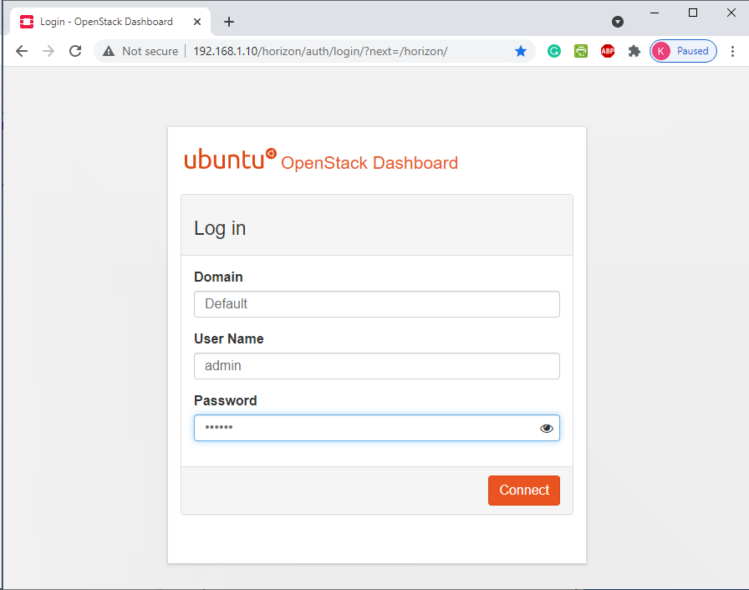

# [Menu Project] Xem thông tin hệ thống OpenStack

## API Access

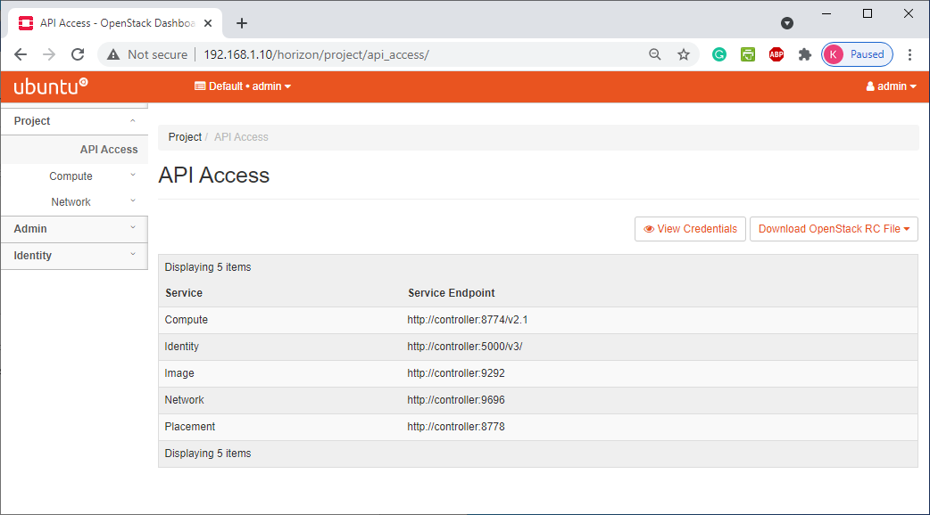

## Project/Compute/Overview

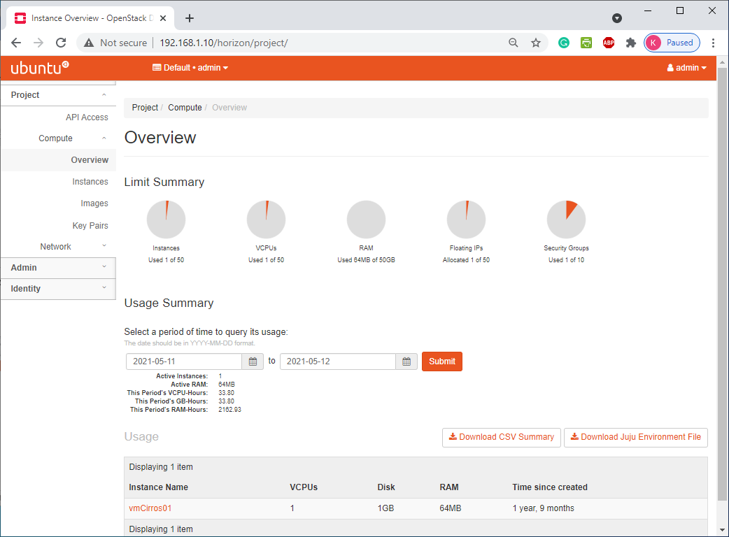

## Project/ Compute/ Instances

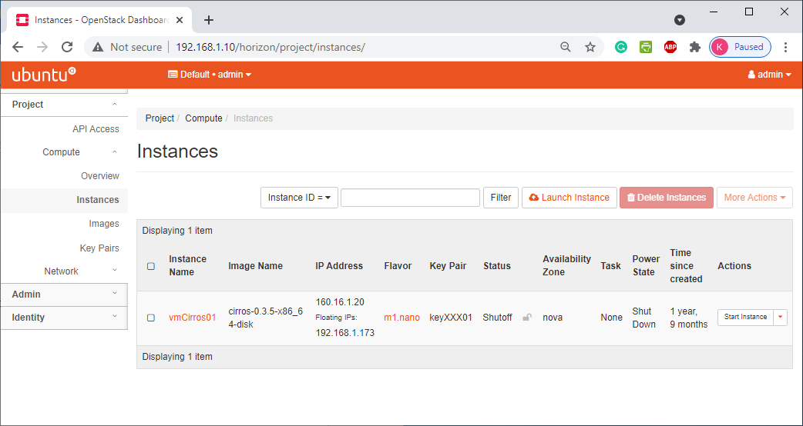

## Project/ Compute/ Images

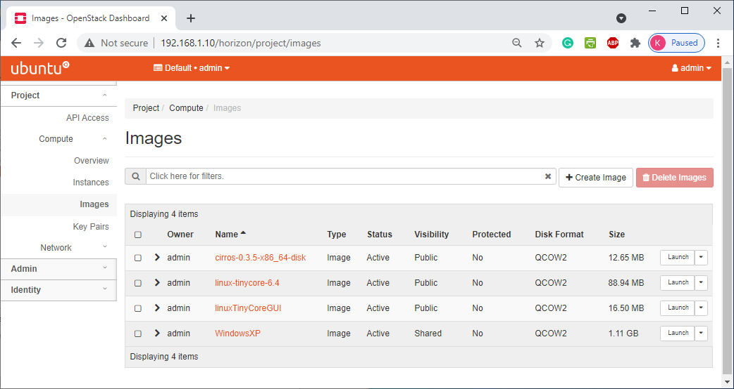

## Project/ Compute/ Key Pairs

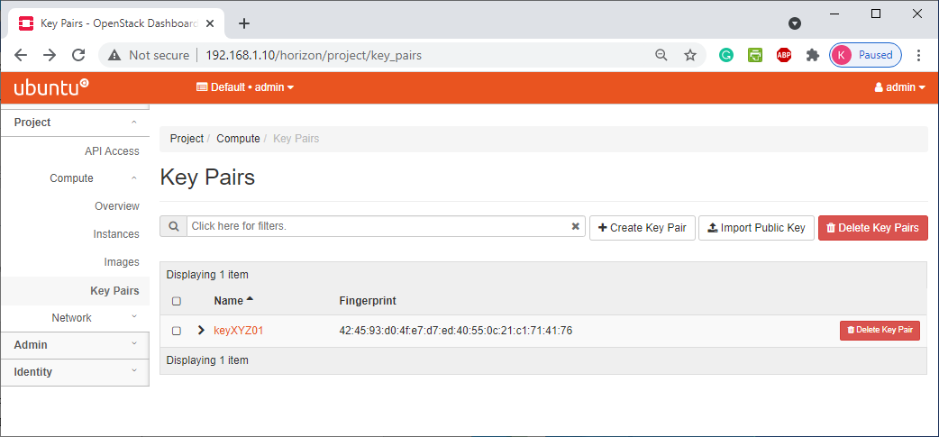

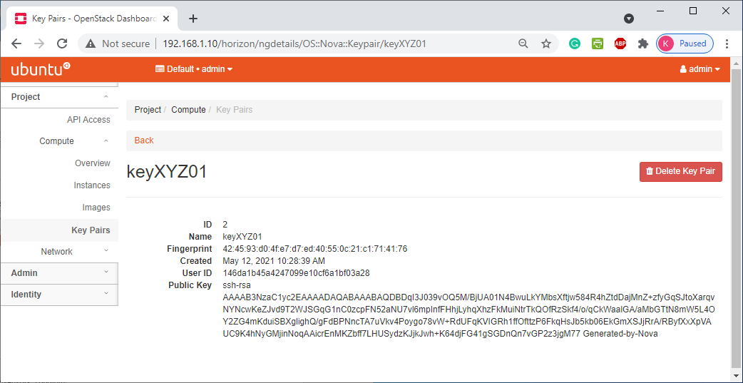

## Project/ Network/ Network Topology

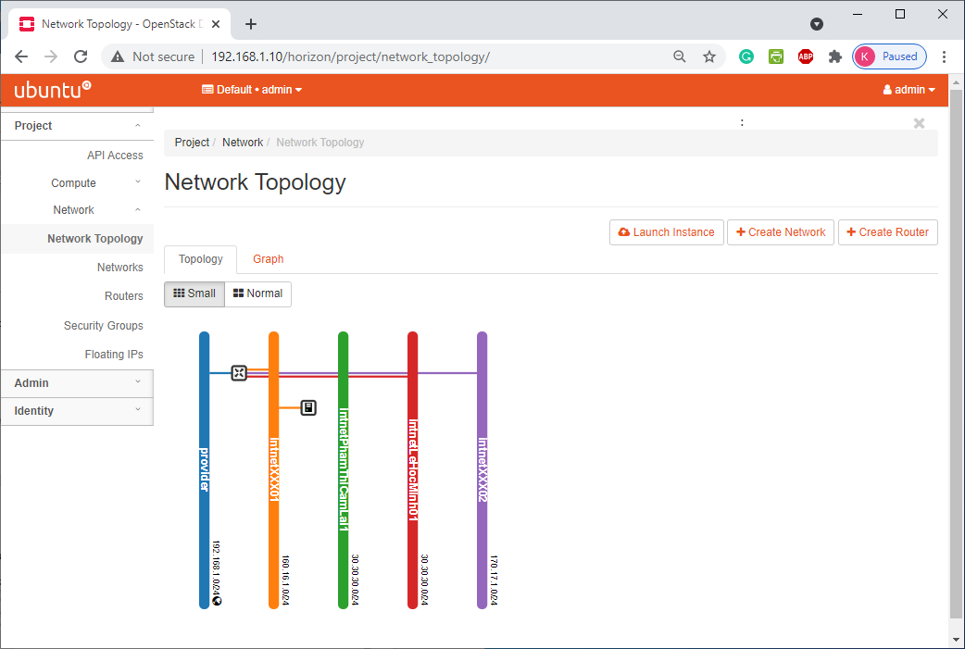

## Project/ Network/ Network Topology

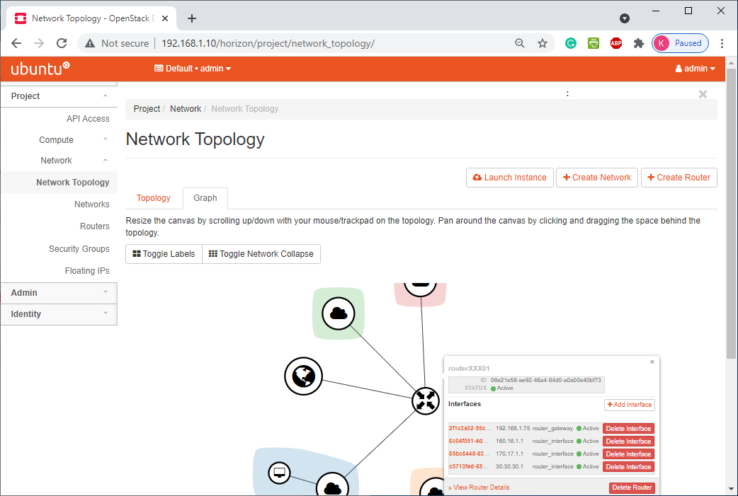

## Project/ Network/ Routers

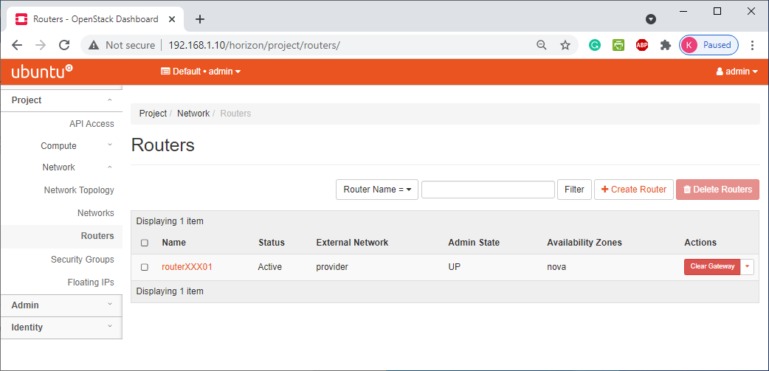

## Project/ Network/ Security Groups

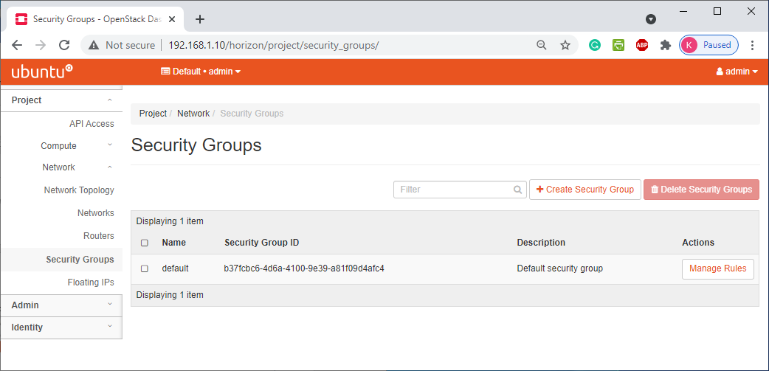

## Project/ Network/ Floating Ips

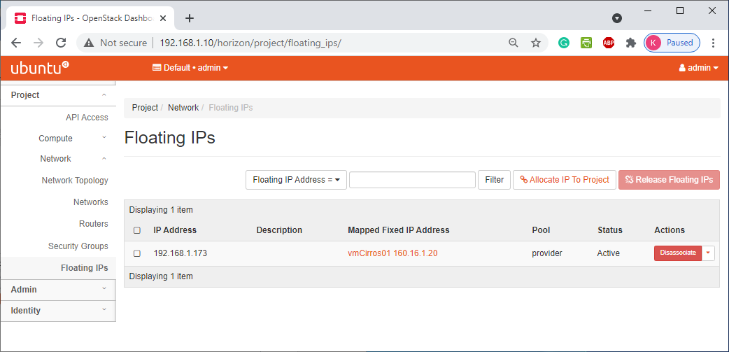

# Memu Admin

## Admin/ Overview

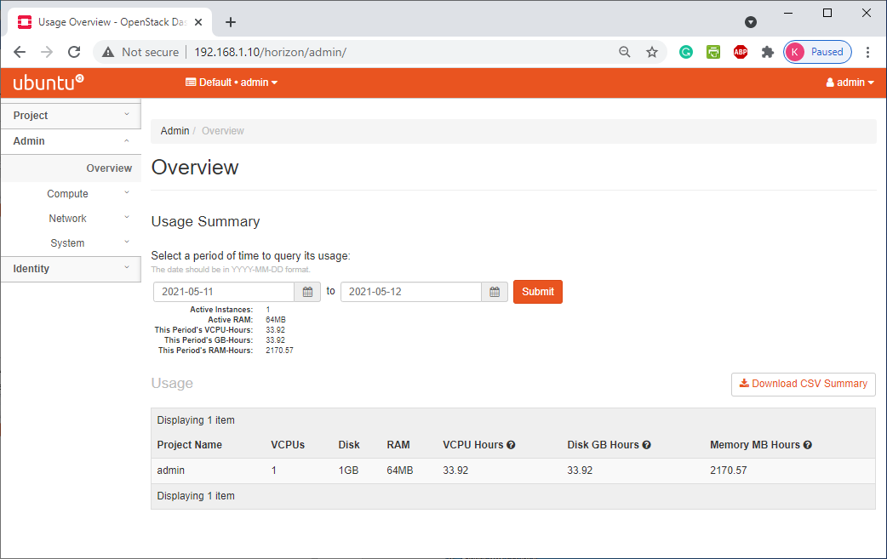

## Admin/ Compute/ Hypervisors

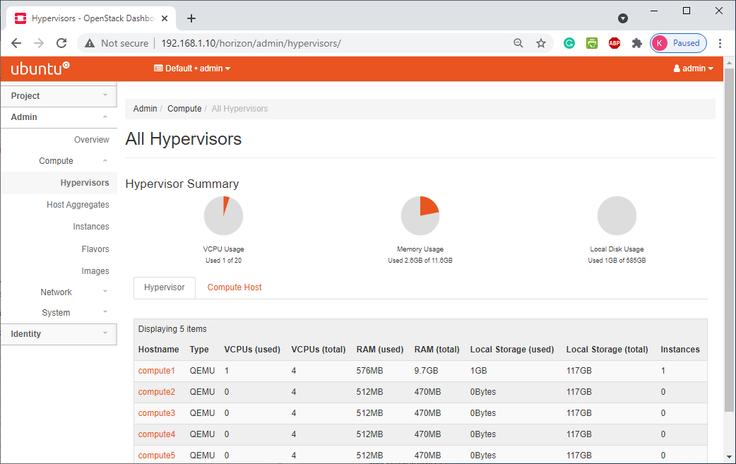

## Admin/ Compute/ Host Aggregates

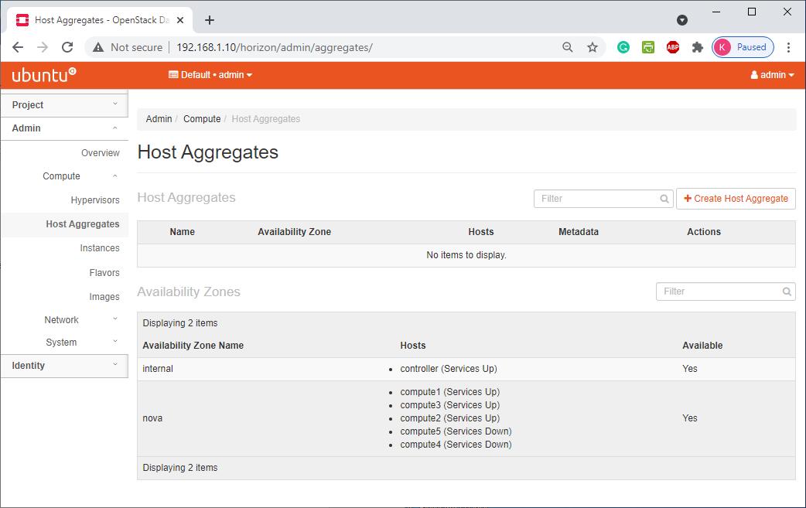

## Admin/ Compute/ Instances

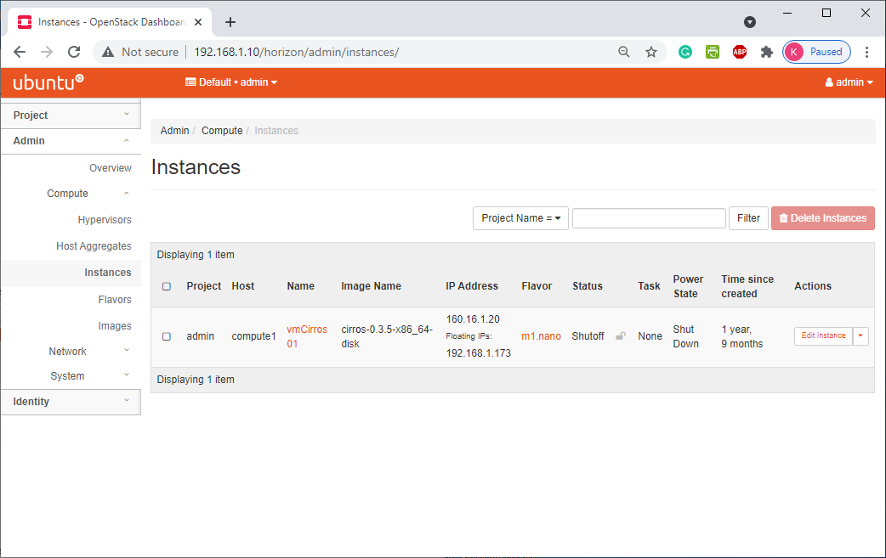

## Admin/ Compute/ Flavors

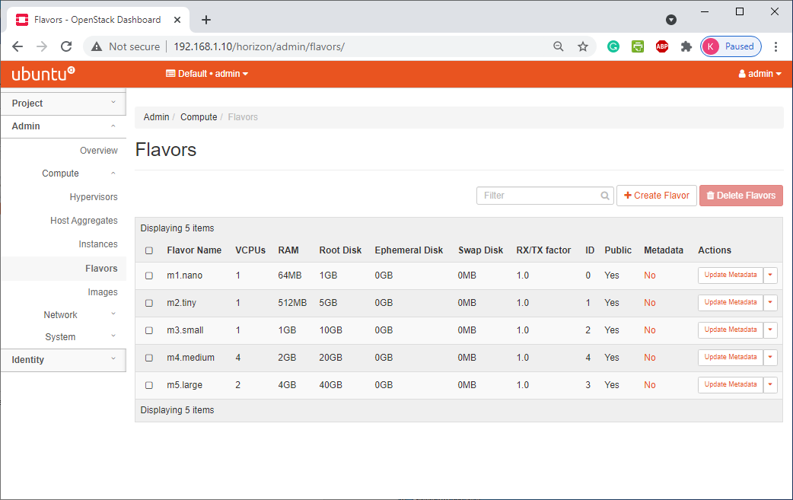

## Admin/ Compute/ Images

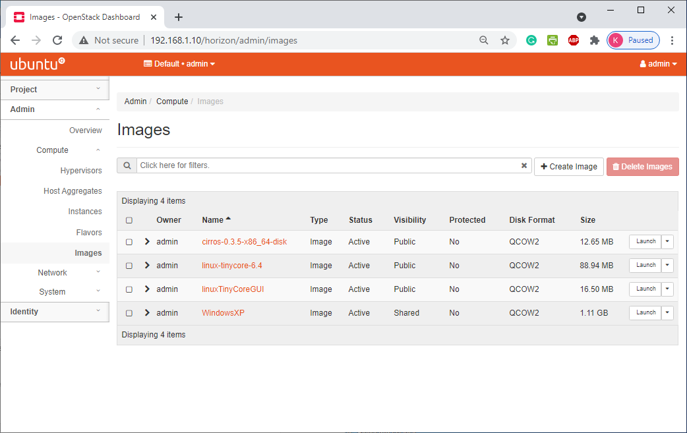

## Admin/ Network/ Networks

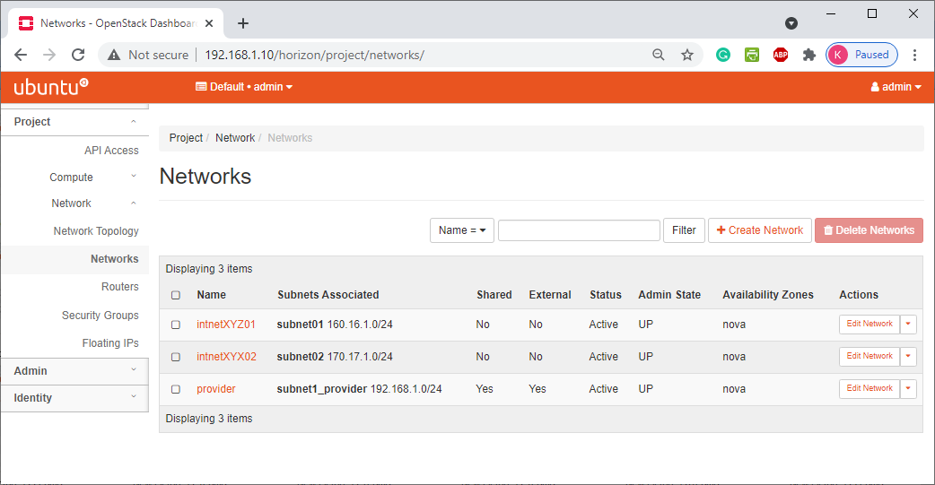

## Admin/ Network/ Routers

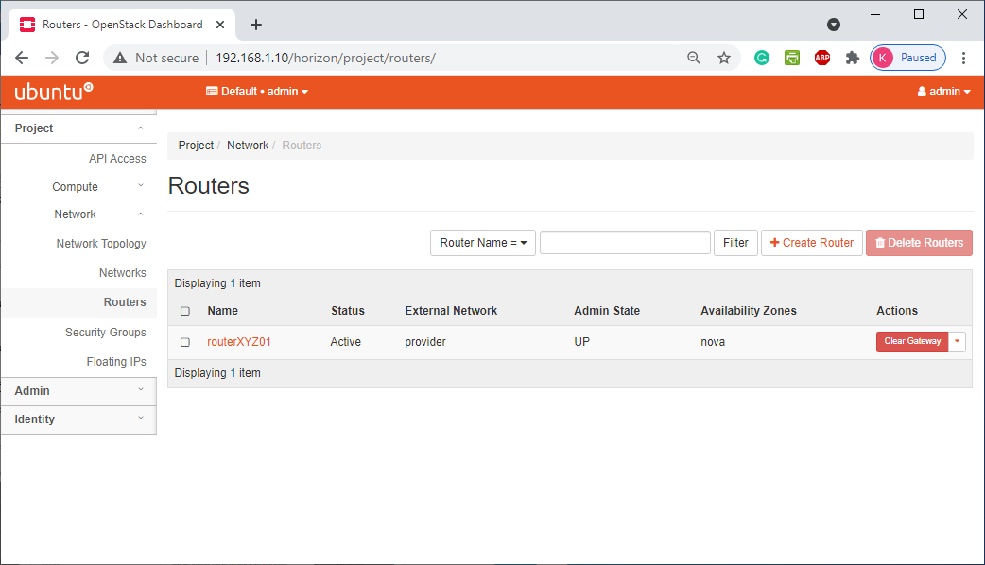

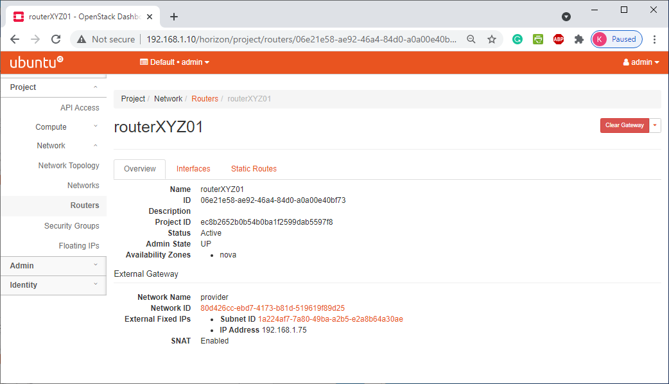

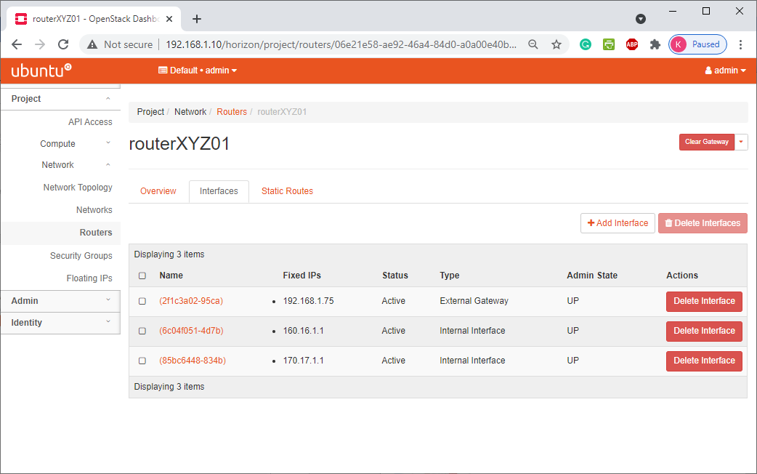

## Admin/ Network/ Floating Ips

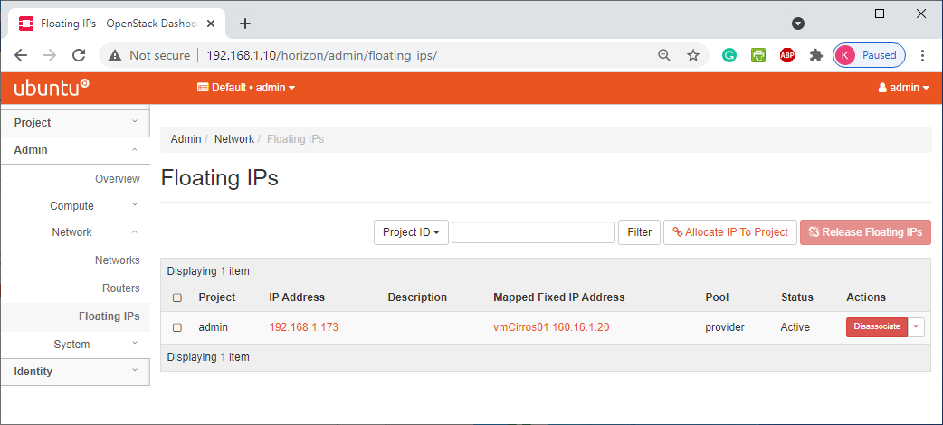

## Admin/ System/ Defaults

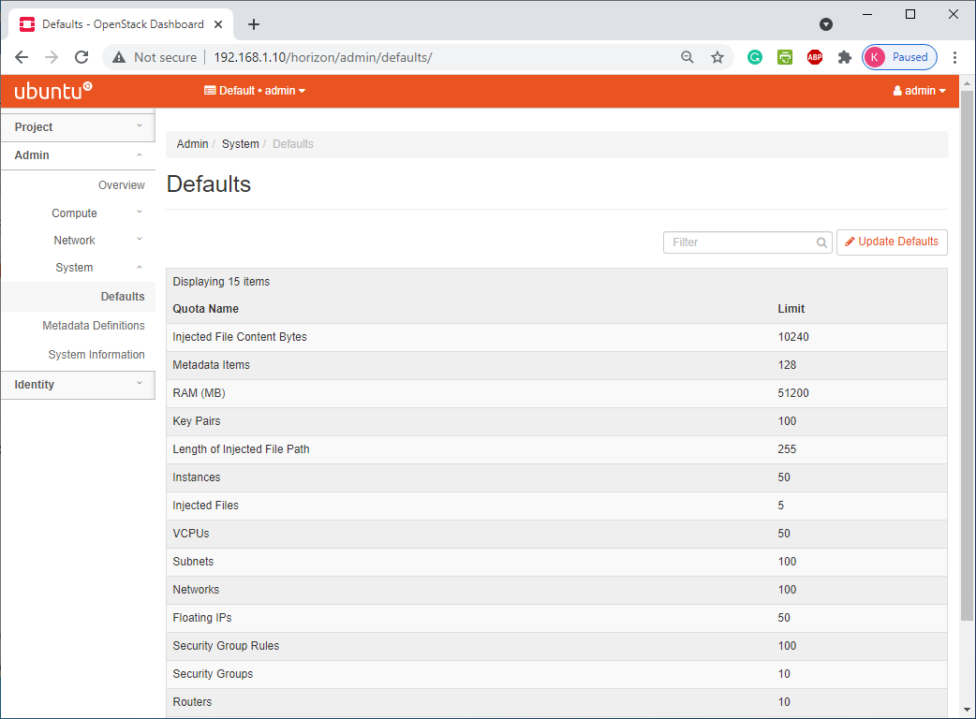

## Admin/ System/ System Information

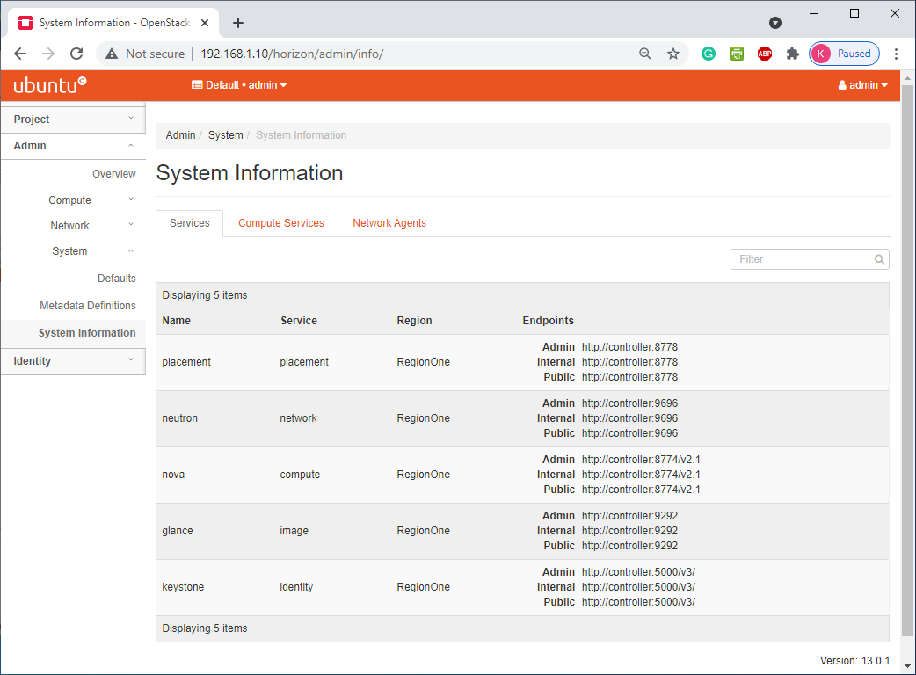

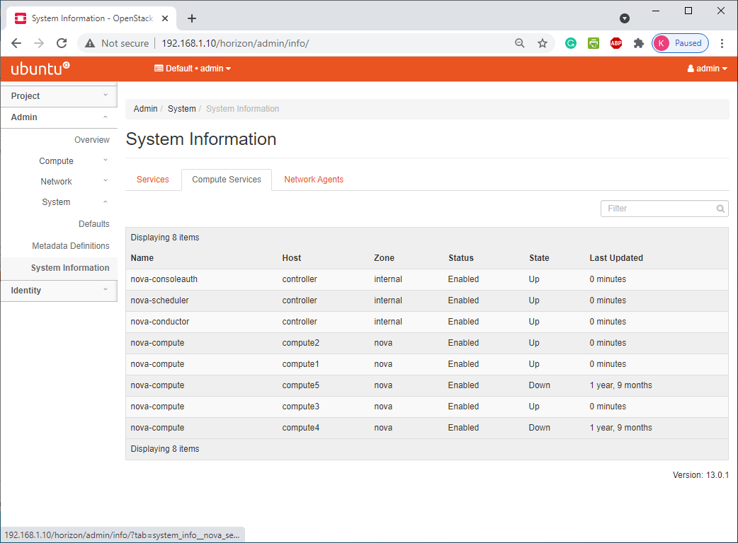

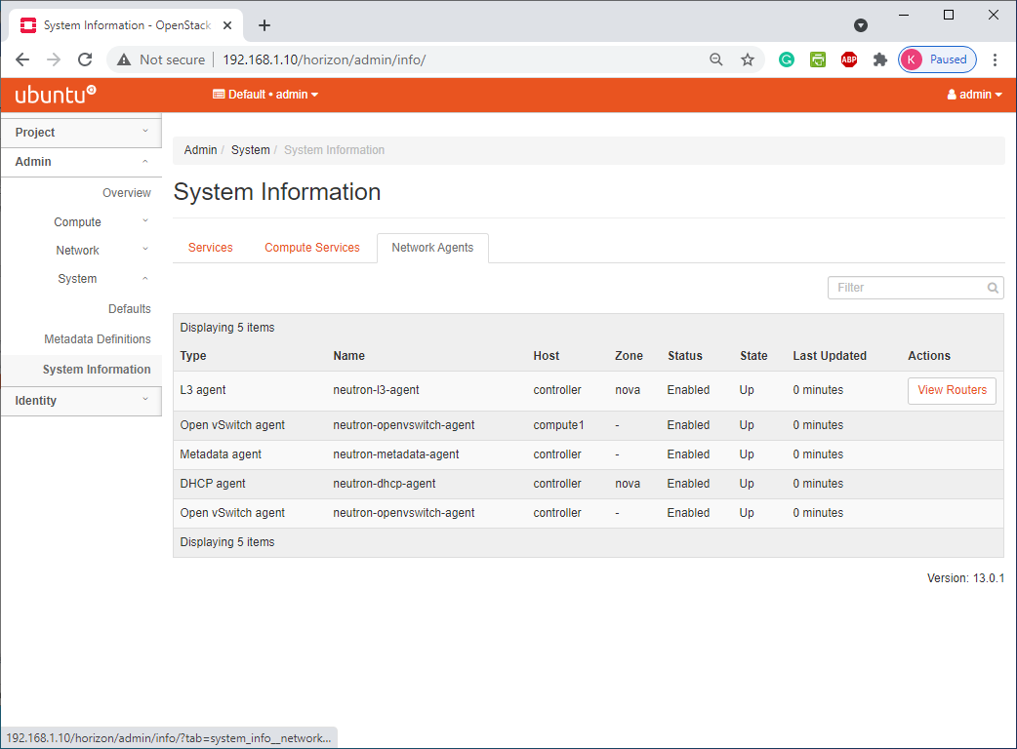

# Menu Identity

## Identity/ Projects

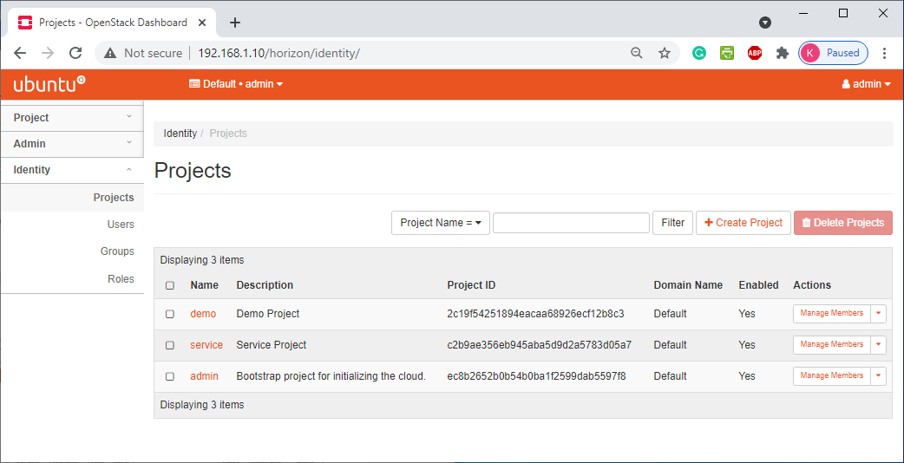

## Identity/ Users

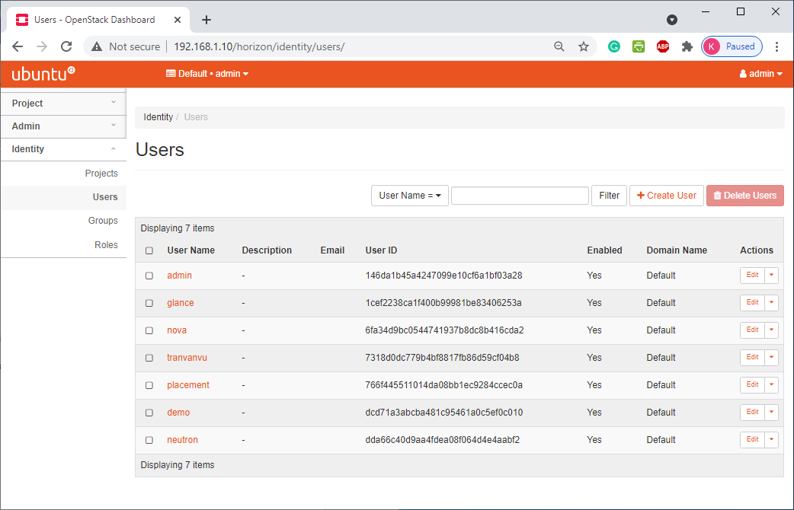

## Identity/ Roles

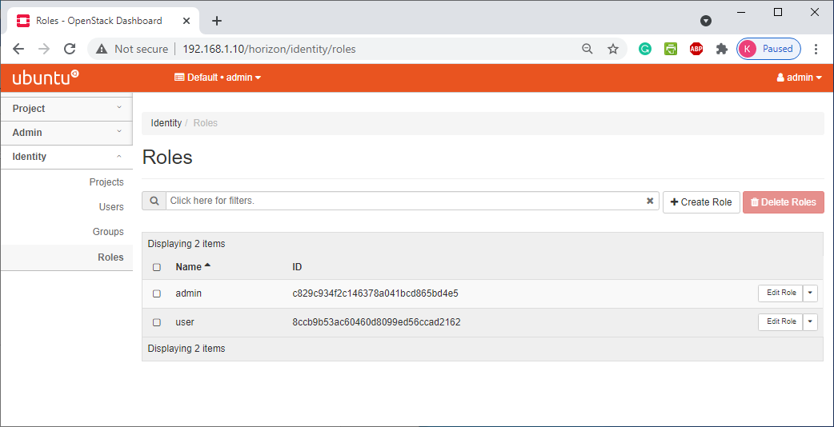

# TẠO MỚI MỘT NETWORK

Chọn menu Project ® Network ® Networks ® Create Network

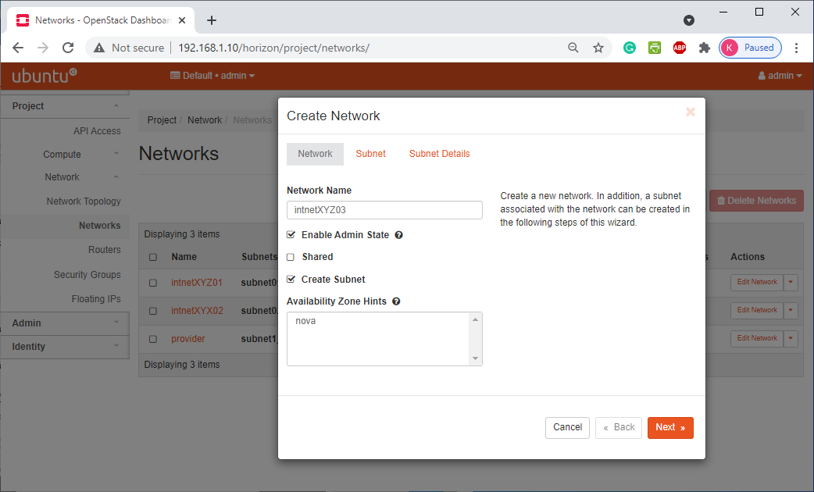

Hình 1.2.1

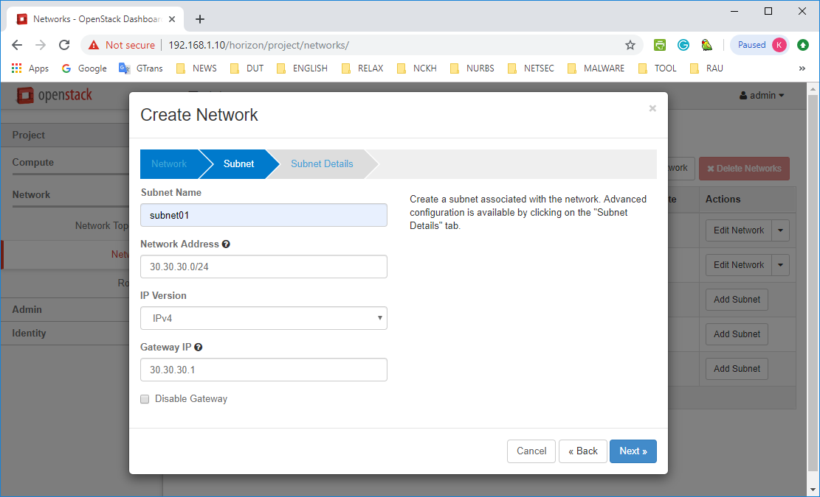

Hình 1.2.2

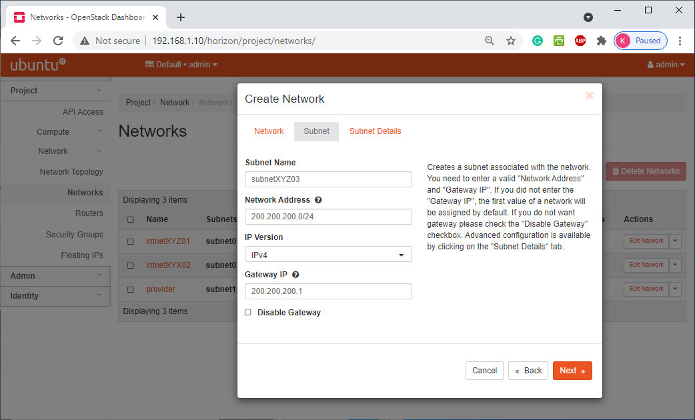

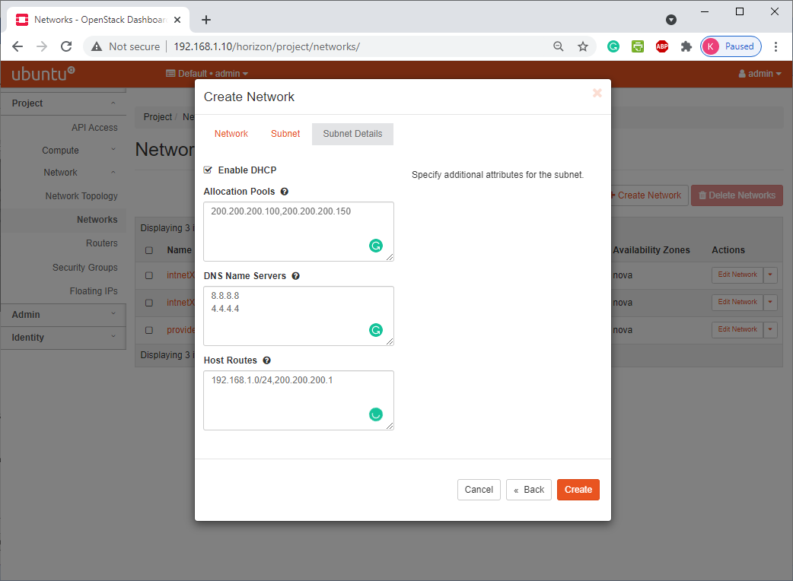

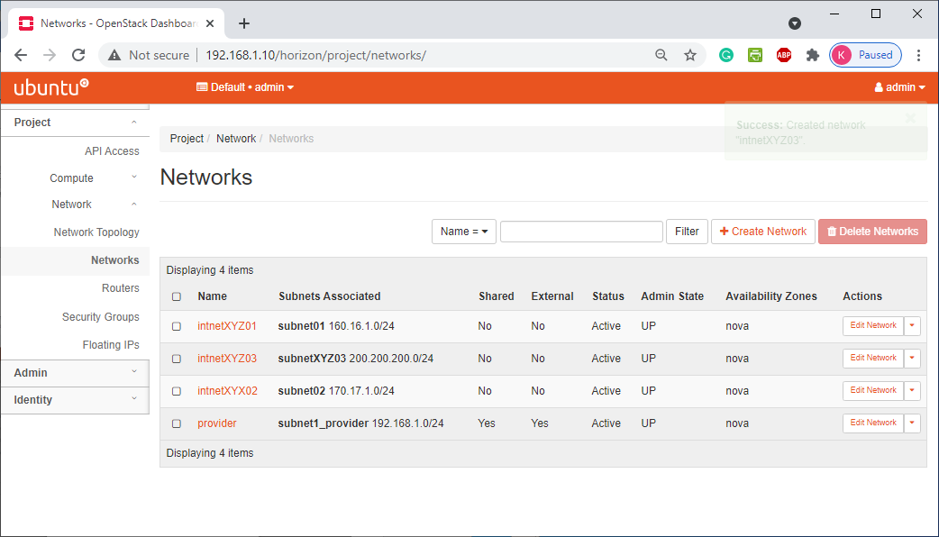

# Tạo mới một route XYZ

Chọn *Project ® Network ® Routers ® Create router*

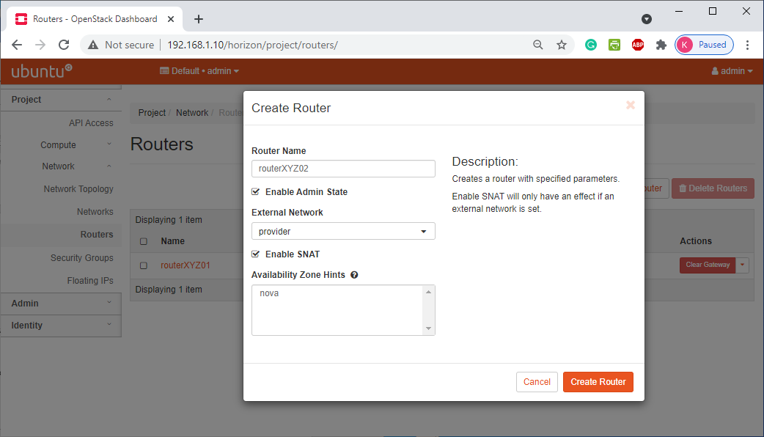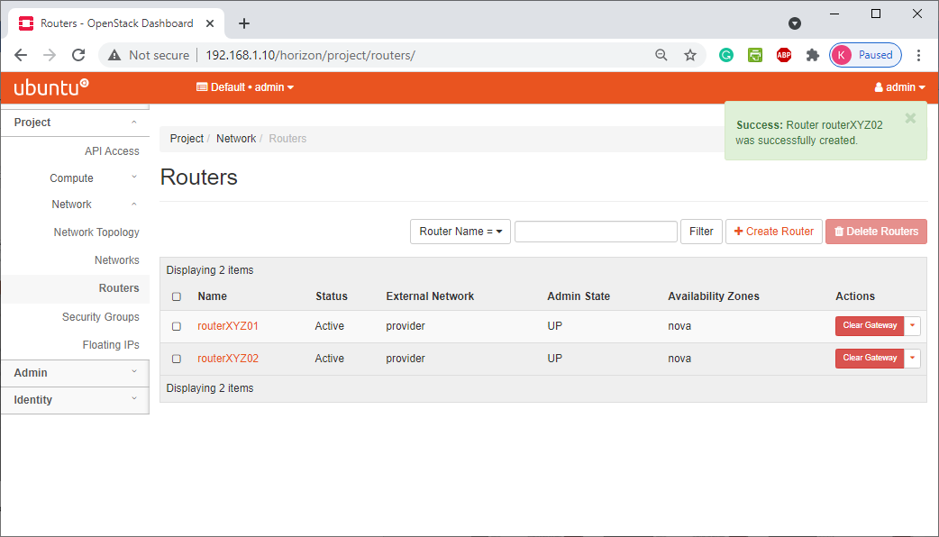

Click chọn RouterXYZ vừa tạo ở bước trên ® Add interface

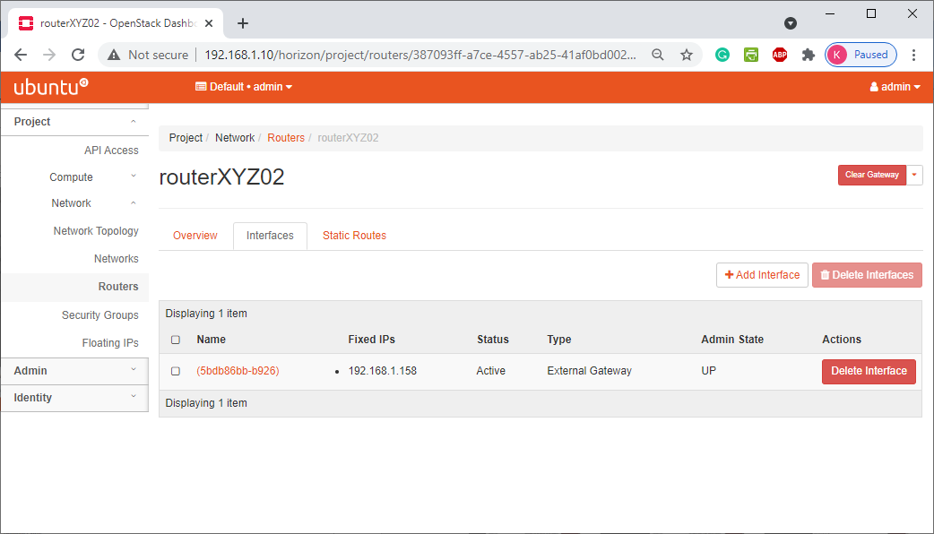

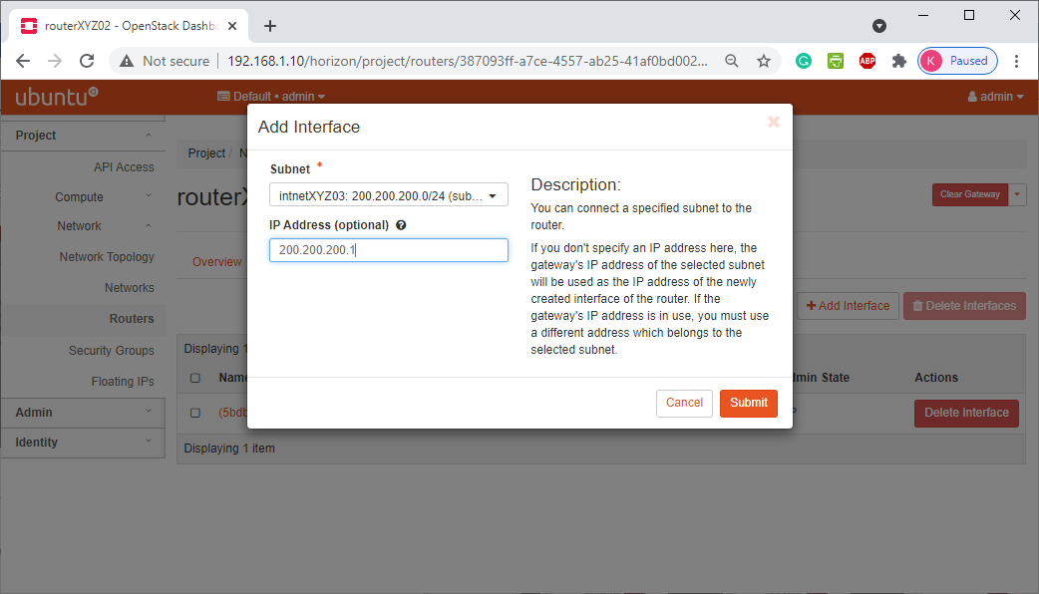

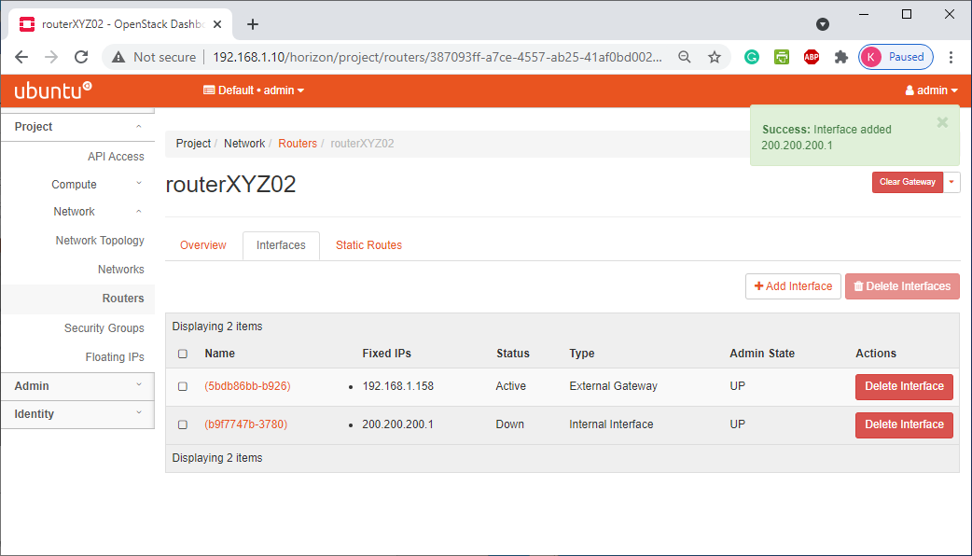

## Project/ Network/ Network Topology

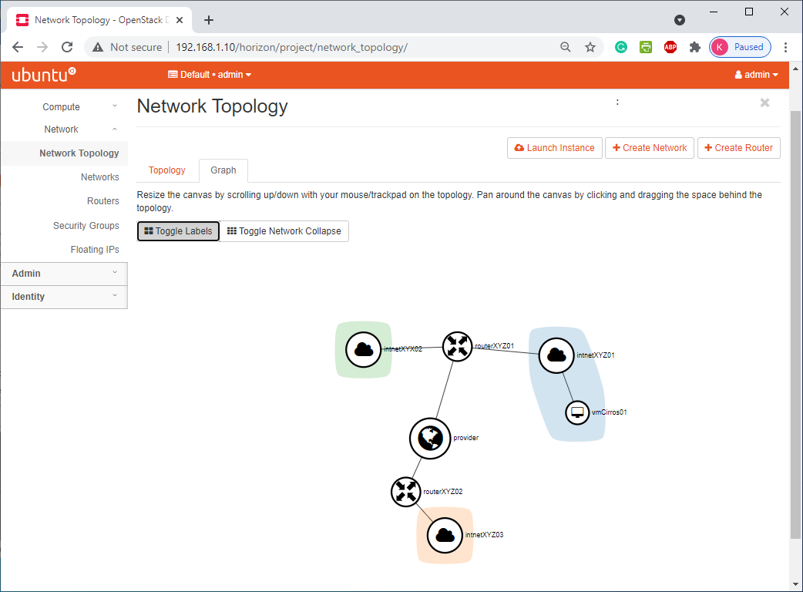

# Tạo keypairs

Project/ Compute/ Key Pairs

Chọn “Create Keypair”, nhập tên như ví dụ sau:

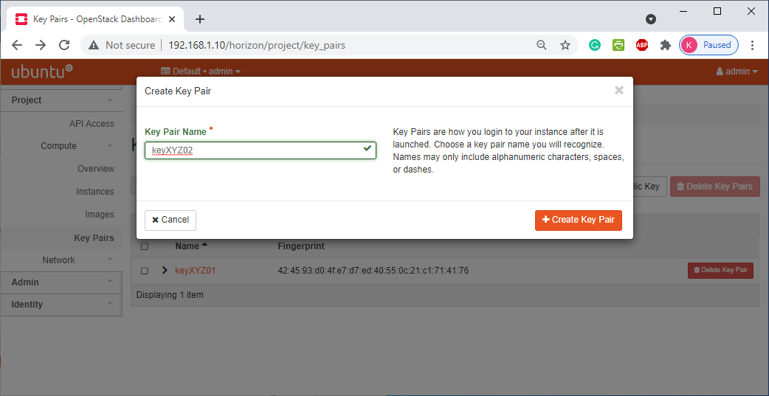

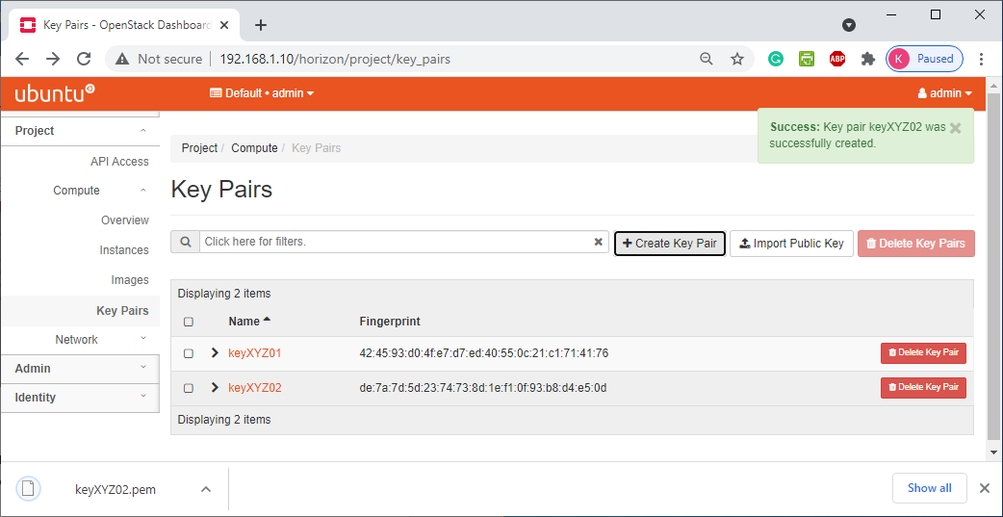

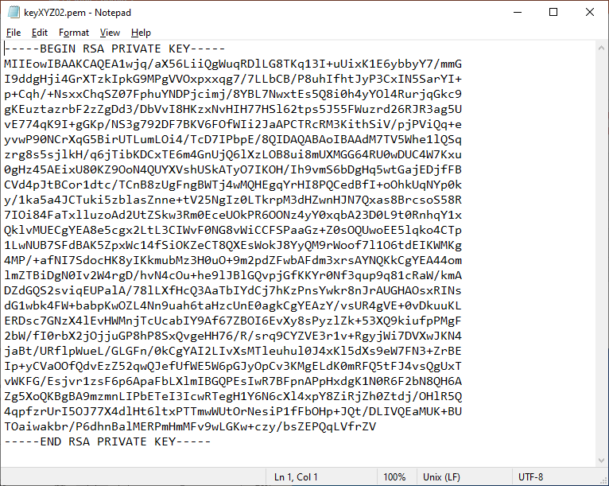

# Tạo các luật cho máy ảo

## Project/ Network/ Security Groups

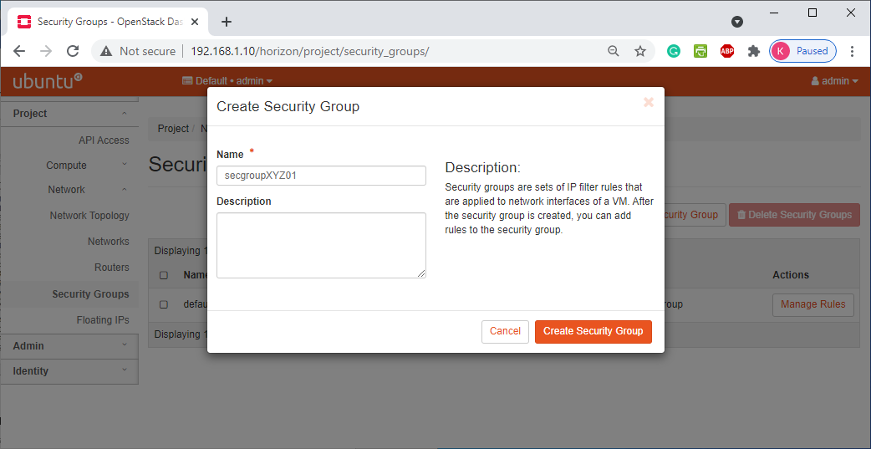

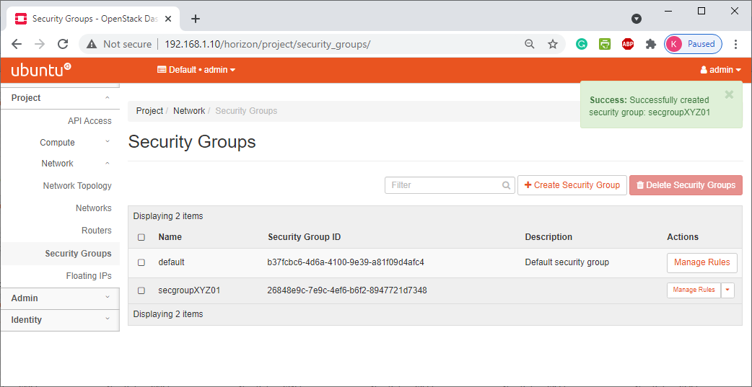

## Tạo rule cho phép bên ngoài truy cập vào máy ảo bằng port 22

Chọn Access & security ® chọn mục “Add rules”

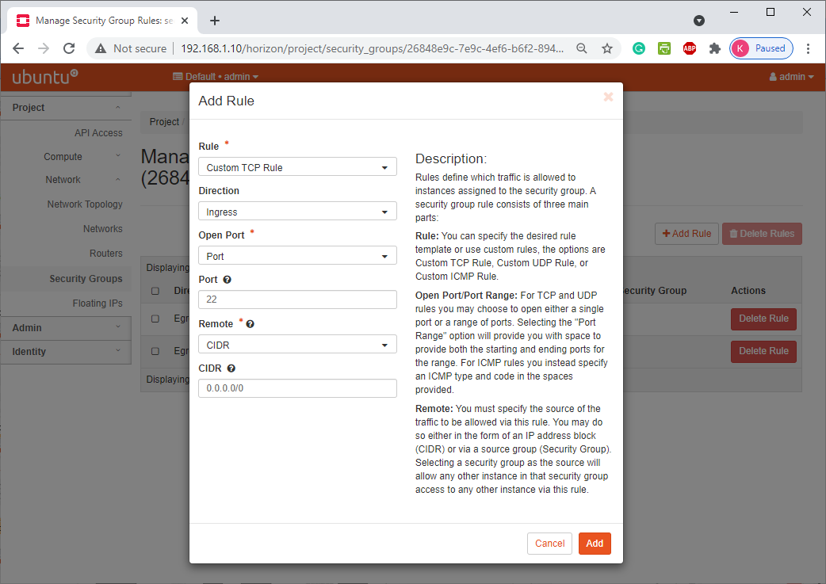

## Tạo rule cho phép bên ngoài ping máy ảo

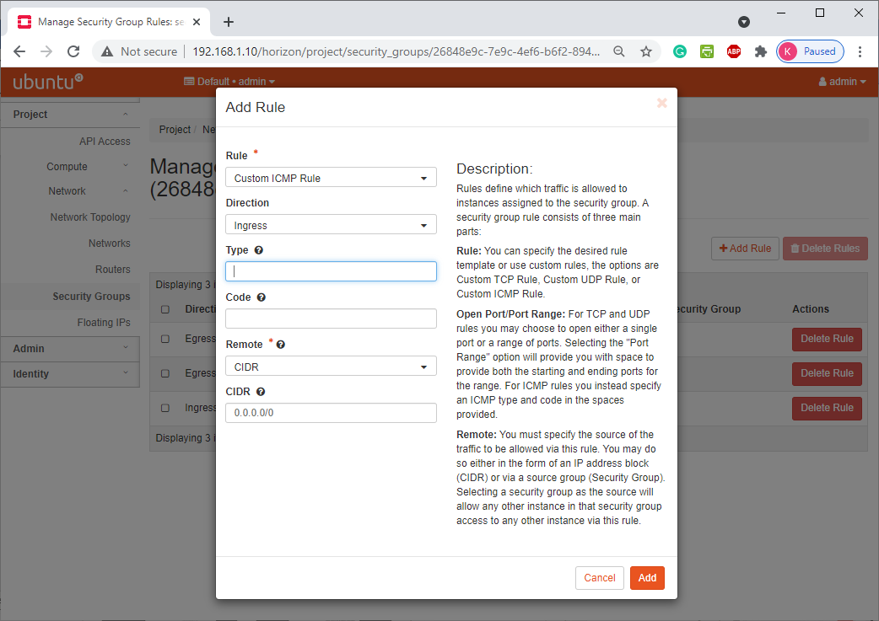

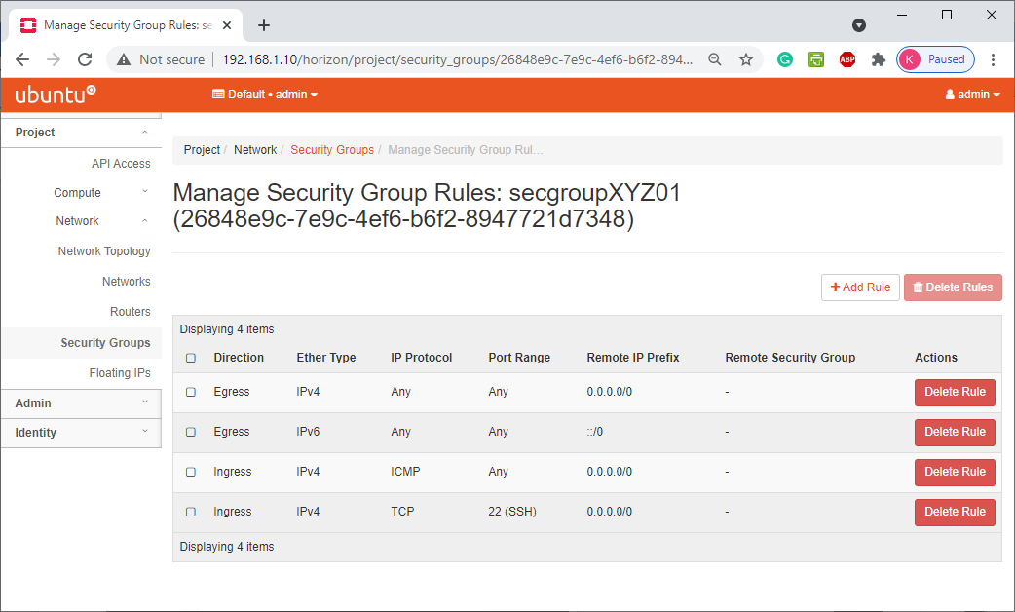

# Tạo máy ảo instance vmXYZ

Chọn Project ® images & snapshots ® chọn Image ® chọn “Launch Instance”

## Project/ Compute/ Instances

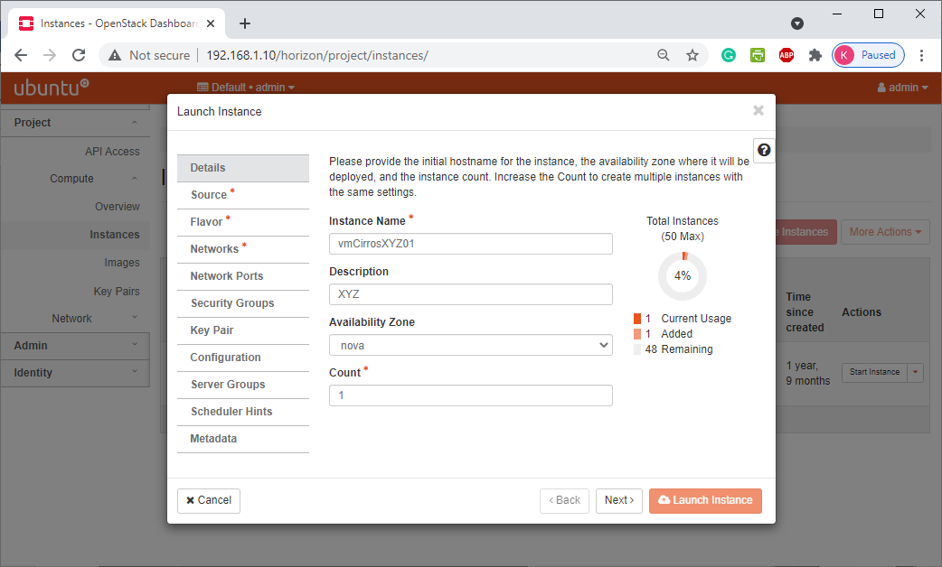

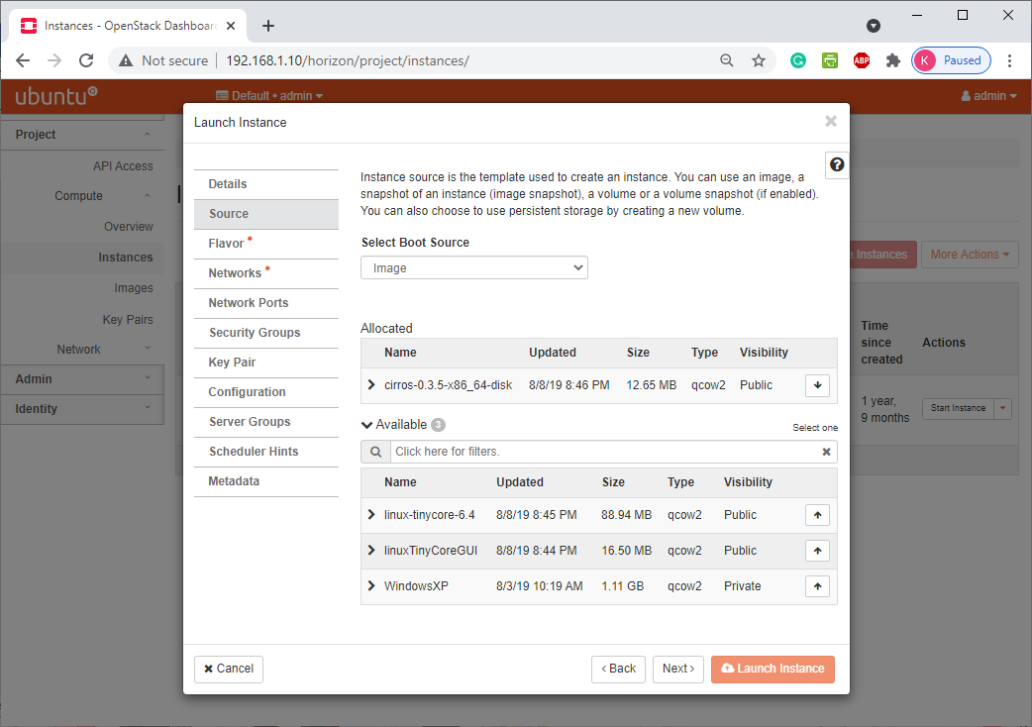

## Chọn cấu hình cho máy ảo (Flavor: m1.tiny)

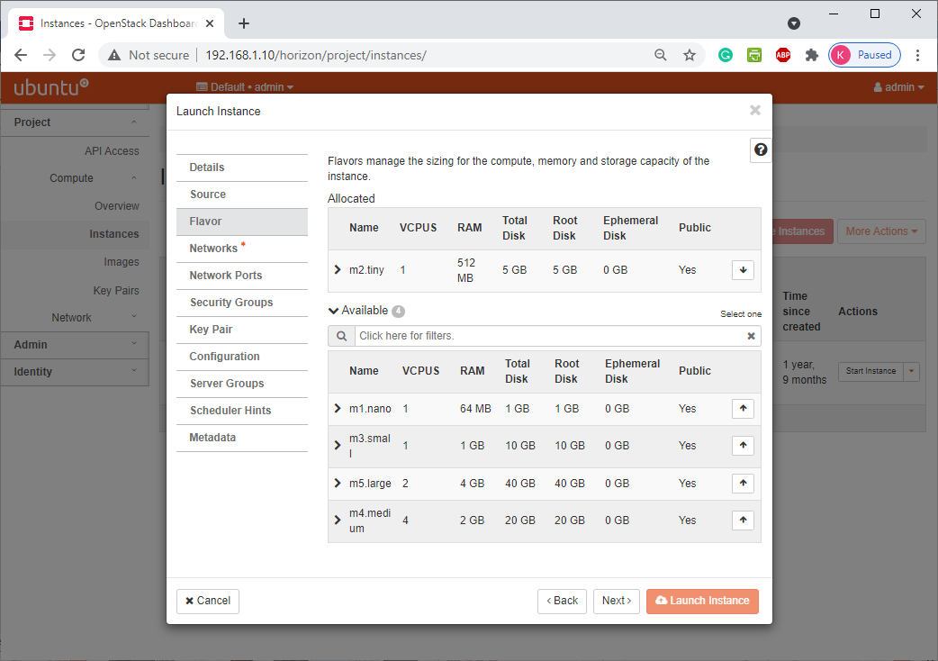

## Chọn Tab Networking. Chọn inetXYZ03.

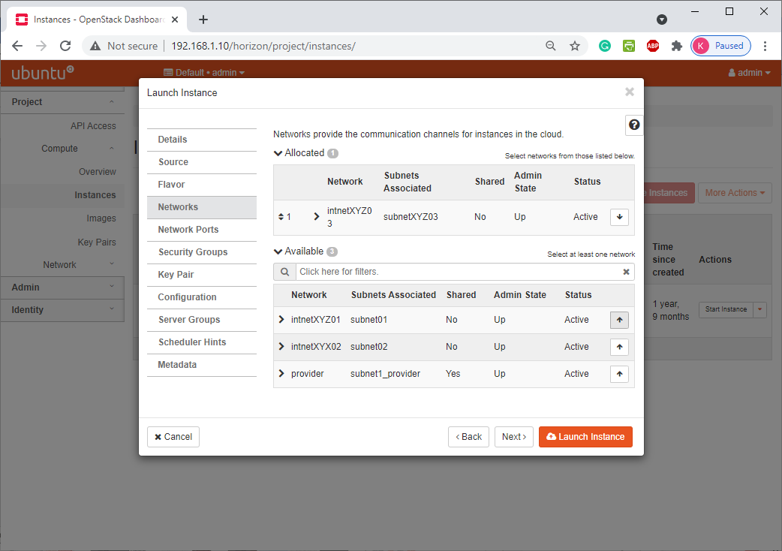

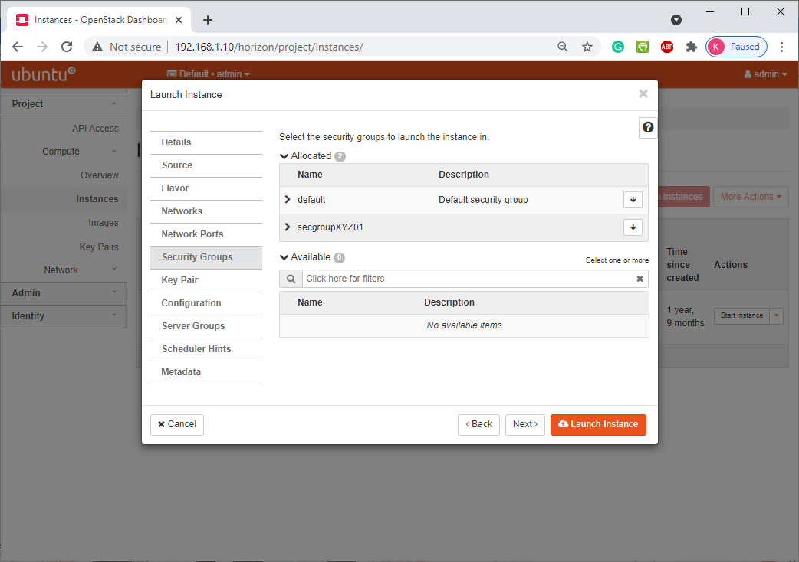

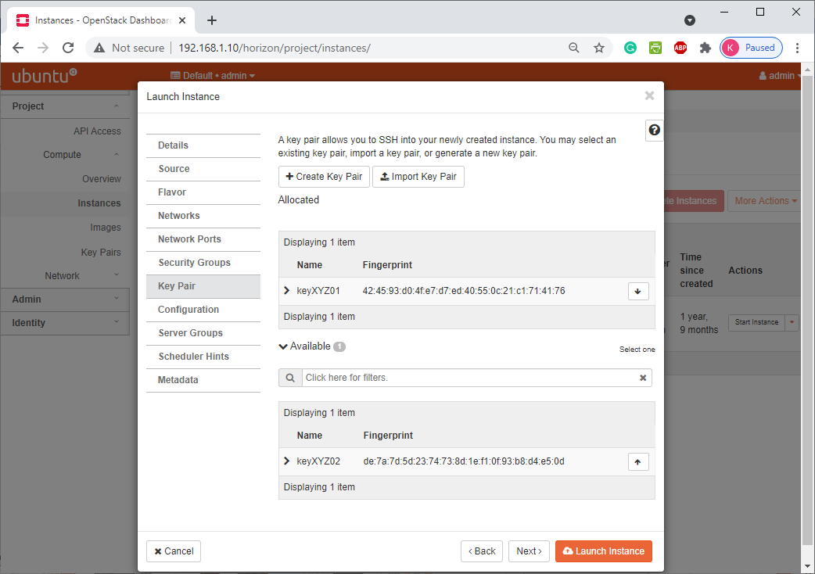

## Chọn nút Launch

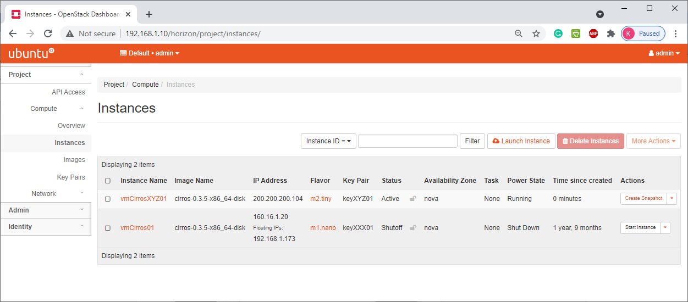

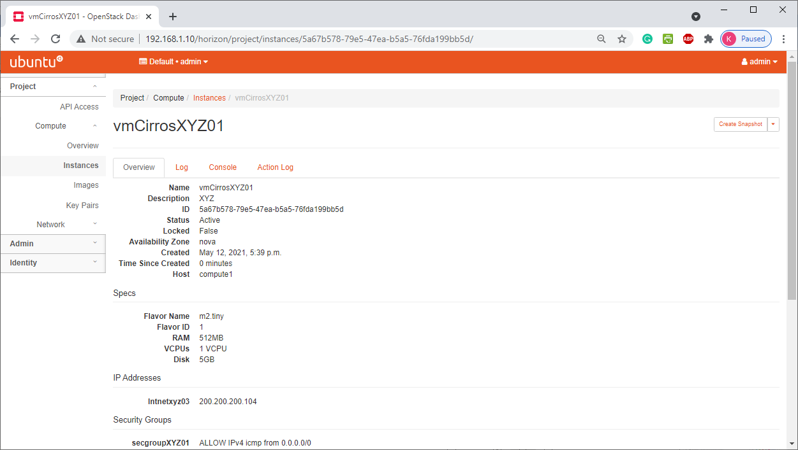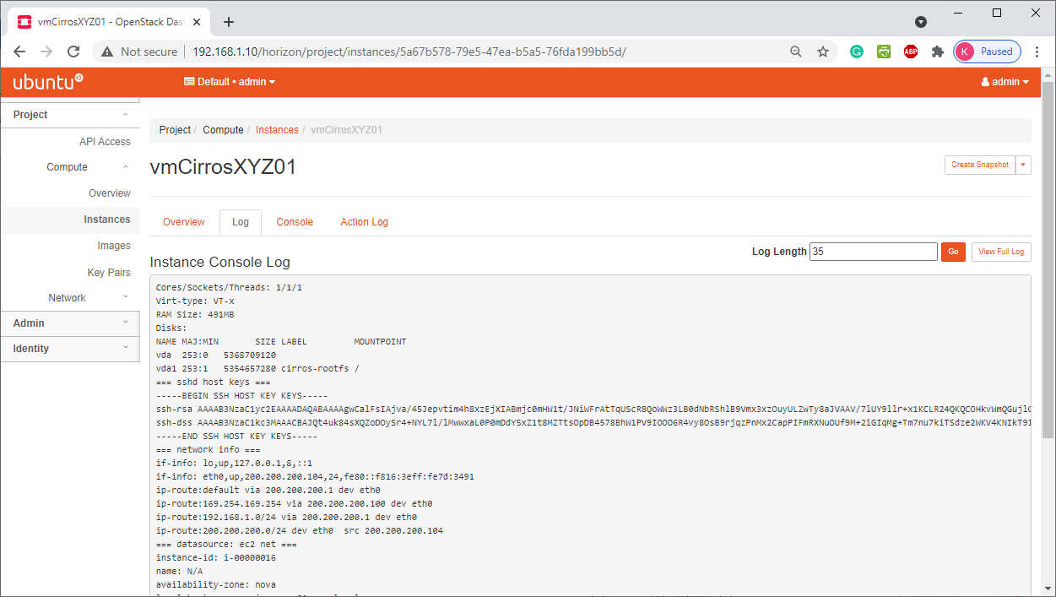

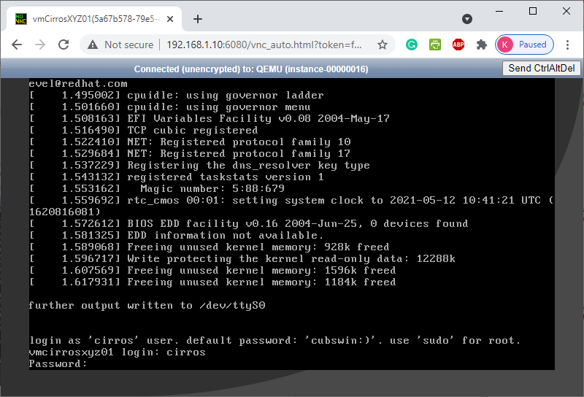

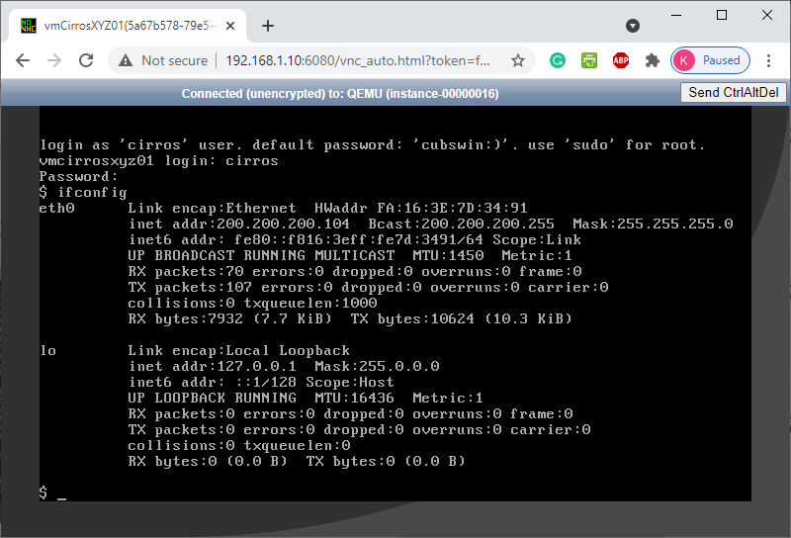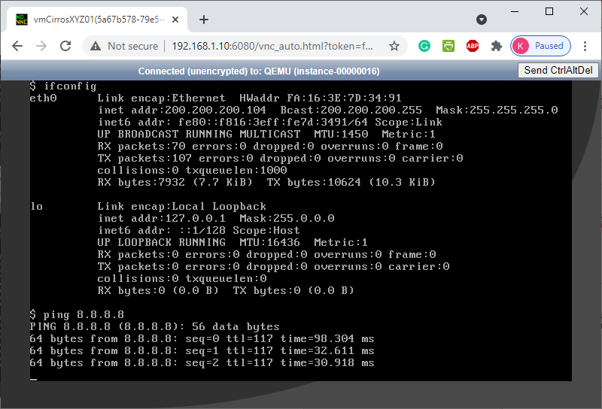

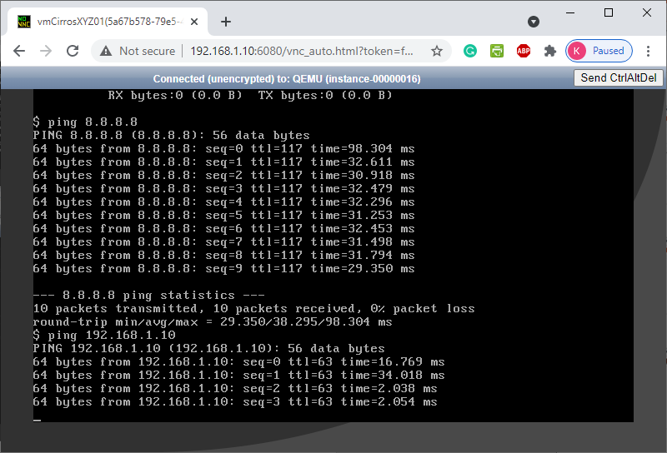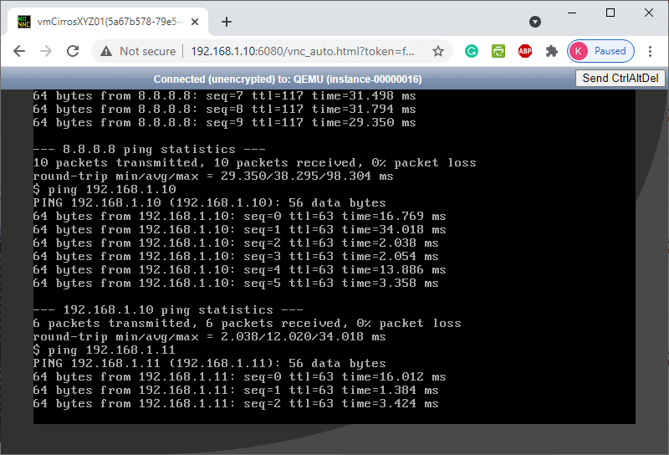 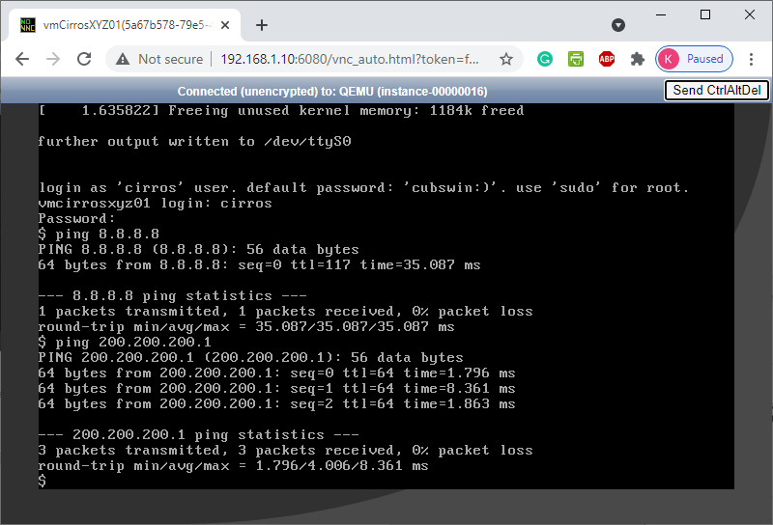

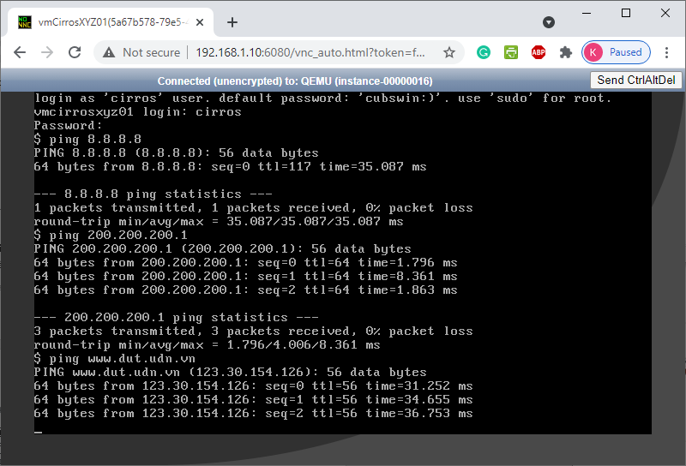

# Tạo và gắn địa chỉ IP floating cho máy instance

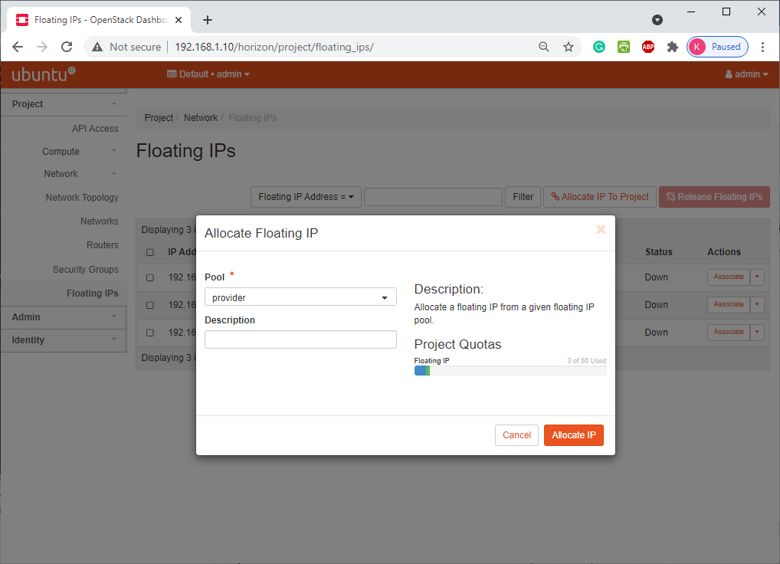

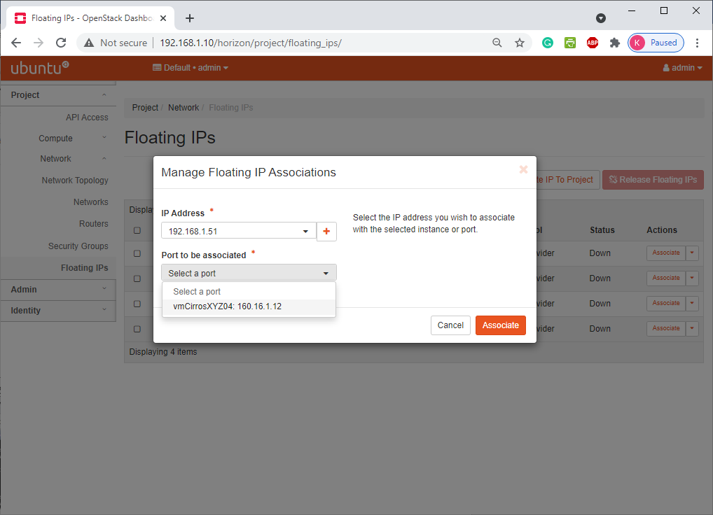

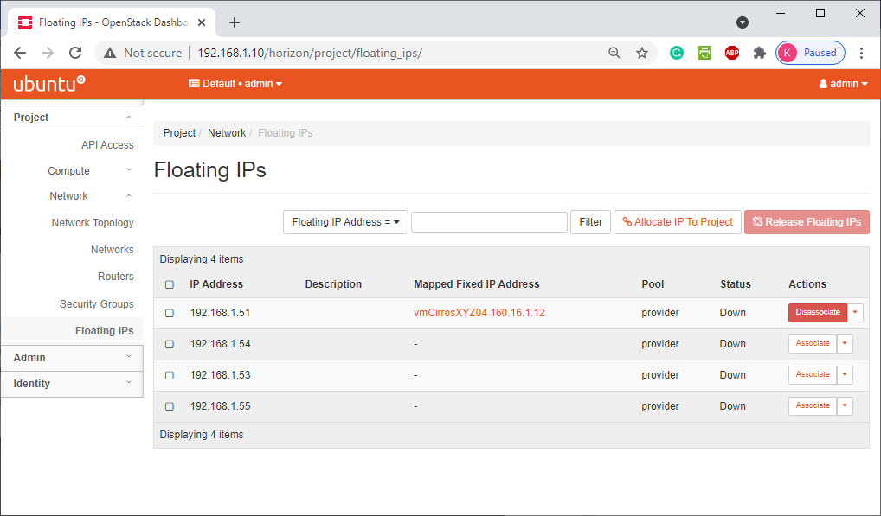

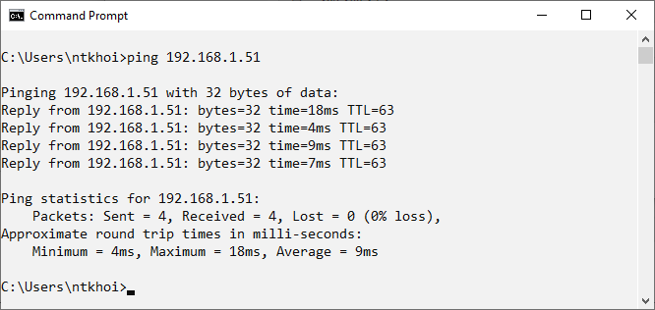

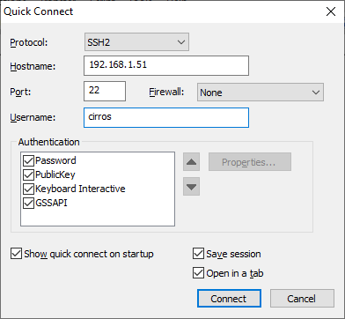

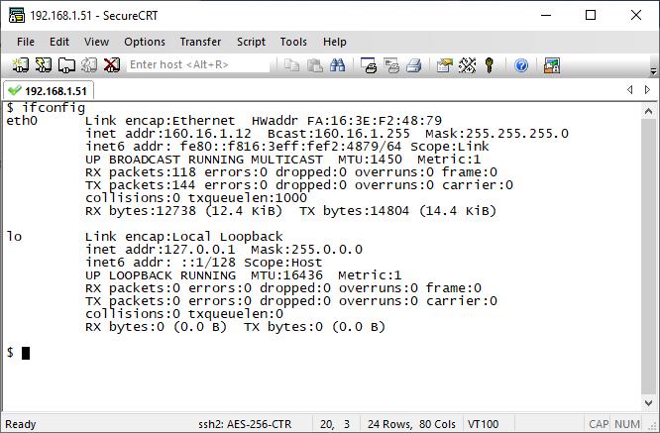

# TÀI LIỆU THAM KHẢO

1. Link mã nguồn dự án: https://github.com/openstack/
2. https://docs.openstack.org/queens/user/
3. https://docs.openstack.org/horizon/queens/user/log-in.html#openstack-dashboard-project-tab
4. ..

(Tài liệu lưu hành nội bộ)

-----------------------------------------------

DANH MỤC HÌNH

**No table of figures entries found.**